UNIVERSITY OF RWANDA
COLLEGE OF SCIENCE AND TECHNOLOGY - SCHOOL OF ICT
DEPARTMENT OF COMPUTER AND SOFTWARE ENGINEERING - NYARUGENGE CAMPUS
MODULE: WEB DESIGN
ELITE'S SHOP
A Web-Based Platform for Buying and Selling Technological Gadgets

Registration No.: 225058527
Year of study: YEAR1 COMPUTER ENGINEERING
Date:19/07/2026

Project Technical Report – Web Design

Table of Contents
UNIVERSITY OF RWANDA 1
Project Technical Report – Web Technology 1
TECHNICAL ASSESSMENT 2026 1
Table of Contents 1
List of Abbreviations 1
Chapter 1. Introduction 1
1.1 Historical Background of the Case Study 1
1.2 Problem Statement 1
1.3 Objectives of the Project 1
1.4 Expected Outcomes 1
1.5 Project Rationale (Importance to the Community) 1
Chapter 2. System Analysis and Design 1
2.1 System Analysis 1
2.1.1 Intended Users of the Project 1
2.1.2 Intended System Partners 1
2.2 System Design 1
2.2.1 High-Level Architecture 1
2.2.2 UI Design and Navigation Flowchart 1
2.2.3 Data Design 1
Chapter 3. Implementation 1
3.1 Introduction of the Section 1
3.2 Landing Page 1
3.3 Seller Login Modal 1
3.4 Shop / Product Catalogue Page 1
3.5 Checkout Page 1
3.6 Seller Dashboard – Add Product 1
3.7 Seller Dashboard – Orders 1
Chapter 4. Conclusion and Recommendation 1
Recommendations 1
Appendix 1

List of Abbreviations
Abbreviation | Meaning
UI | User Interface
UX | User Experience
HTML | HyperText Markup Language
CSS | Cascading Style Sheets
JS | JavaScript
DOM | Document Object Model
CRUD | Create, Read, Update, Delete
Frw | Rwandan Francs

Chapter 1. Introduction

1.1 Historical Background of the Case Study
Buying and selling technological gadgets such as smartphones, laptops, and accessories in Rwanda is commonly done informally, through physical shops, word of mouth, or unstructured social media and messaging-app posts. Sellers of gadgets, including individual resellers and small shops, often lack a dedicated, organized online storefront where customers can browse available products, see prices clearly, and place orders in a structured way. ELITE's Shop (branded on-page as "Eliteone Shop") was developed to address this gap by providing a simple, dedicated web platform where a shop owner can list tech gadgets for sale and customers can browse, search, and order them online.

1.2 Problem Statement
Small tech gadget sellers typically have no affordable, easy-to-use website to showcase their products and receive orders. Customers, in turn, have no single place to browse a seller's full catalogue, search for a specific item, and submit an order with their delivery details. Existing informal sales channels make it difficult to track orders, confirm what has been sold, and manage inventory. This project addresses the problem by providing a two-sided web platform: a shop front for buyers and a management dashboard for the seller.

1.3 Objectives of the Project
The general objective of this project is to design and implement ELITE's Shop, a web-based buying and selling platform for technological gadgets. The specific objectives are to:
- Provide a landing page that lets a visitor choose to continue as a Buyer or log in as a Seller.
- Allow buyers to browse a catalogue of gadgets, search products by name, and place an order through a checkout form.
- Provide secure seller login access to a dedicated seller dashboard.
- Allow the seller to add new products (name, price, and image) and remove existing ones.
- Allow the seller to view all buyer orders and mark them as completed.

1.4 Expected Outcomes
By the end of this project, ELITE's Shop delivers a functional client-side web application consisting of four linked pages: a landing page, a shop/catalogue page, a checkout page, and a seller dashboard. Buyers are expected to be able to browse products, search by name, and submit an order with their contact and delivery details. The seller is expected to be able to log in, add and remove products with images, and review and manage incoming orders, all without needing a separate installation.

1.5 Project Rationale (Importance to the Community)
A dedicated buying and selling platform benefits both sides of the transaction. For a small gadget seller, it provides a low-cost storefront that is easier to share and manage than informal channels, and it keeps a running record of orders received. For customers, it offers a clear, searchable catalogue with visible prices and a straightforward way to place an order, improving trust and convenience compared to negotiating purchases informally. More broadly, tools like this support small-scale digital entrepreneurship and make technology retail more accessible in the local market.

Chapter 2. System Analysis and Design

2.1 System Analysis

2.1.1 Intended Users of the Project
- Buyer – any visitor who browses the shop, searches for products, and places orders.
- Seller / Shop Owner – the administrator who logs in to add products and manage incoming orders.

2.1.2 Intended System Partners
- The owner of ELITE's Shop (Eliteone Shop), as the operator of the platform.
- Individual gadget suppliers/resellers who could, in future, be onboarded as additional sellers.
- Potential future partners for payment processing (e.g. mobile money) and delivery/logistics, which are not yet integrated.

2.2 System Design

2.2.1 High-Level Architecture
ELITE's Shop is currently implemented as a client-side-only web application: there is no backend server or database. All pages are static HTML/CSS/JavaScript, and application data — the seller's login state, seller-added products, and buyer orders — is persisted directly in the browser using sessionStorage and localStorage, as shown in Figure 1.
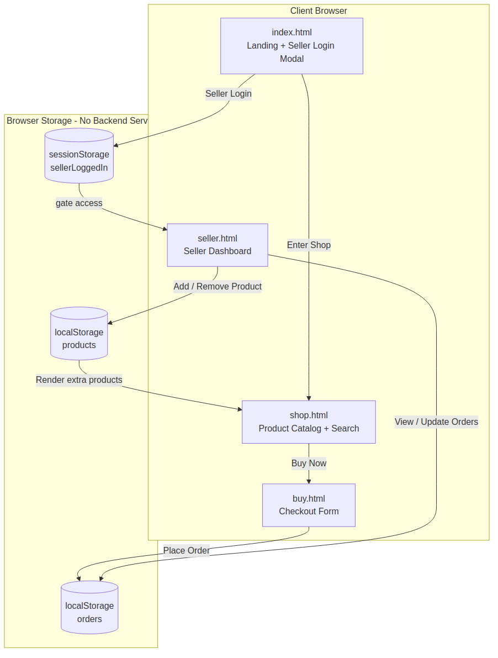
Figure 1: High-level architecture of ELITE's Shop
The landing page (index.html) routes visitors either into the shop (shop.html) or, after a successful seller login, into the seller dashboard (seller.html). The seller login state is kept in sessionStorage for the duration of the browser session. Products added by the seller and orders placed by buyers are both persisted in localStorage as JSON arrays, which the shop and dashboard pages read from and write to directly using client-side JavaScript, with no server-side API or database involved at this stage.

2.2.2 UI Design and Navigation Flowchart
Figure 2 shows the navigation flow of the application, from the landing page through the buyer path (browse → buy → checkout) and the seller path (login → dashboard → add product / manage orders).
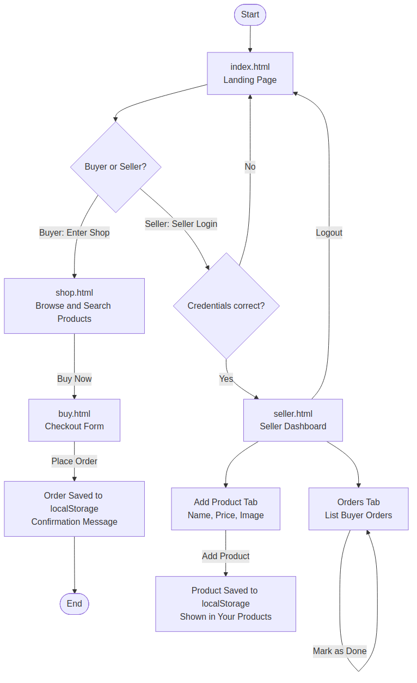
Figure 2: UI navigation flowchart

2.2.3 Data Design
Because the current version does not use a relational database, the data design is expressed as JSON record structures stored in the browser rather than as a formal Entity Relationship Diagram (ERD). The three data structures used are:
- Product — { name, price, image } — stored in the localStorage "products" array and created via the seller dashboard's Add Product form.
- Order — { id, buyerName, email, product, price, quantity, address, date, status } — stored in the localStorage "orders" array and created via the checkout form.
- Session flag — sellerLoggedIn — stored in sessionStorage and used to gate access to the seller dashboard.
A Product is referenced by name and price inside an Order at the time of purchase (rather than through a foreign key), since there is no database layer linking the two collections. Formalizing this into a relational schema — with a Products table, an Orders table, and a foreign key from Order to Product — is recommended future work and is discussed further in Chapter 4.

Chapter 3. Implementation

3.1 Introduction of the Section
This chapter presents the implemented ELITE's Shop web application through screenshots of the working system, captured directly from the deployed pages. Each screenshot is accompanied by a caption and a short discussion of its functionality and how it connects to the design presented in Chapter 2.

3.2 Landing Page
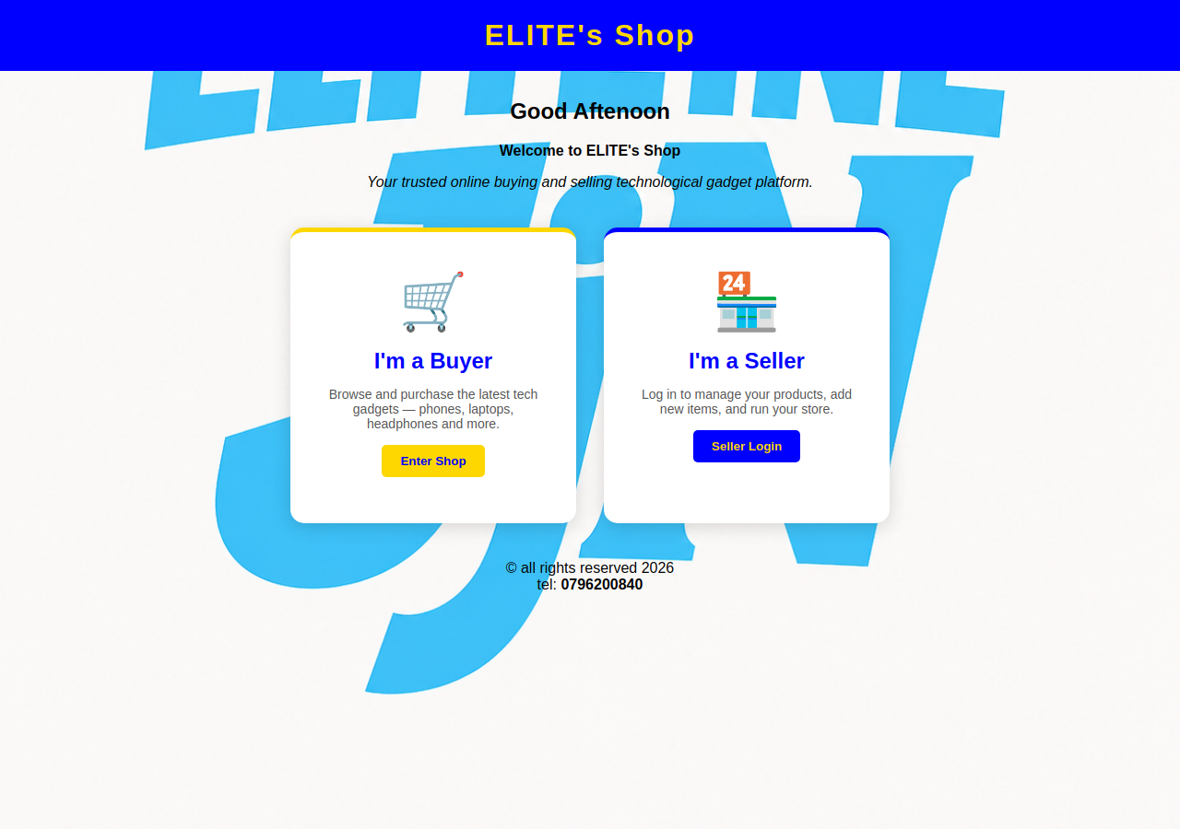
Figure 3: Landing page (index.html)
The landing page greets the visitor with a time-based message generated in JavaScript ("Good Morning", "Good Afternoon", or "Good Evening" depending on the browser's current time) and presents two role cards: "I'm a Buyer", which links directly to shop.html, and "I'm a Seller", which opens a login modal. The page also displays the shop's contact number and copyright footer.

3.3 Seller Login Modal
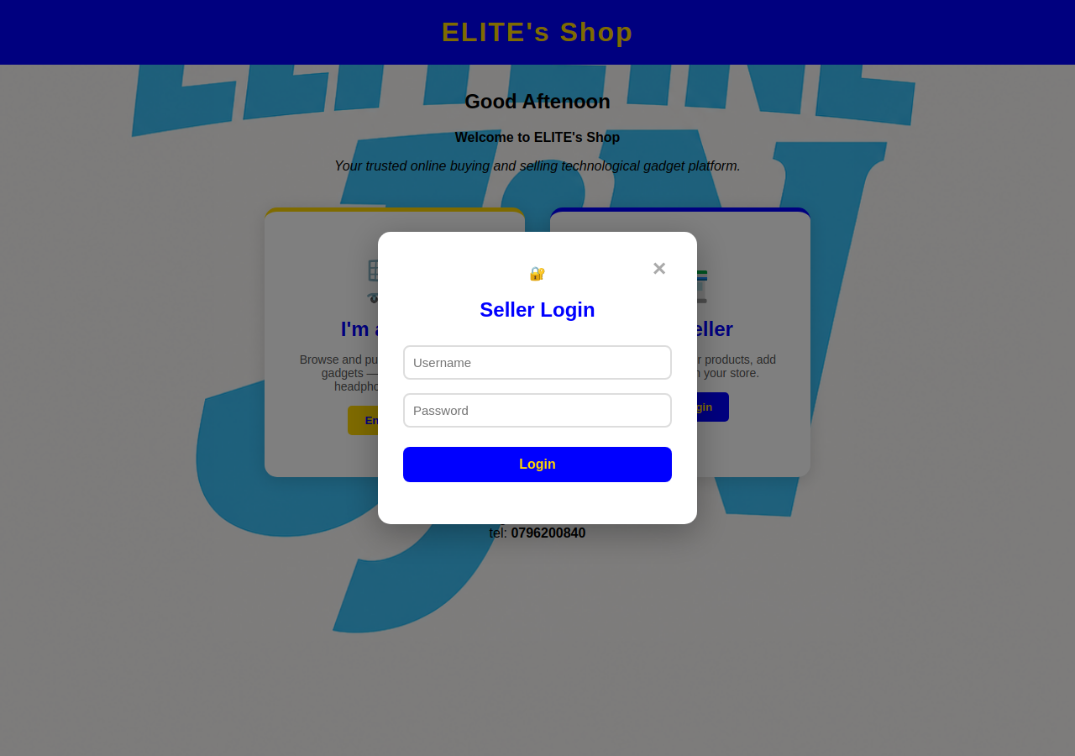
Figure 4: Seller login modal
Clicking "I'm a Seller" opens a modal overlay with username and password fields. The credentials are validated in JavaScript against a hardcoded seller username and password; on success, a sellerLoggedIn flag is written to sessionStorage and the browser is redirected to seller.html. On failure, an inline error message ("Incorrect username or password") is displayed. Submitting the form with the Enter key is also supported.

3.4 Shop / Product Catalogue Page
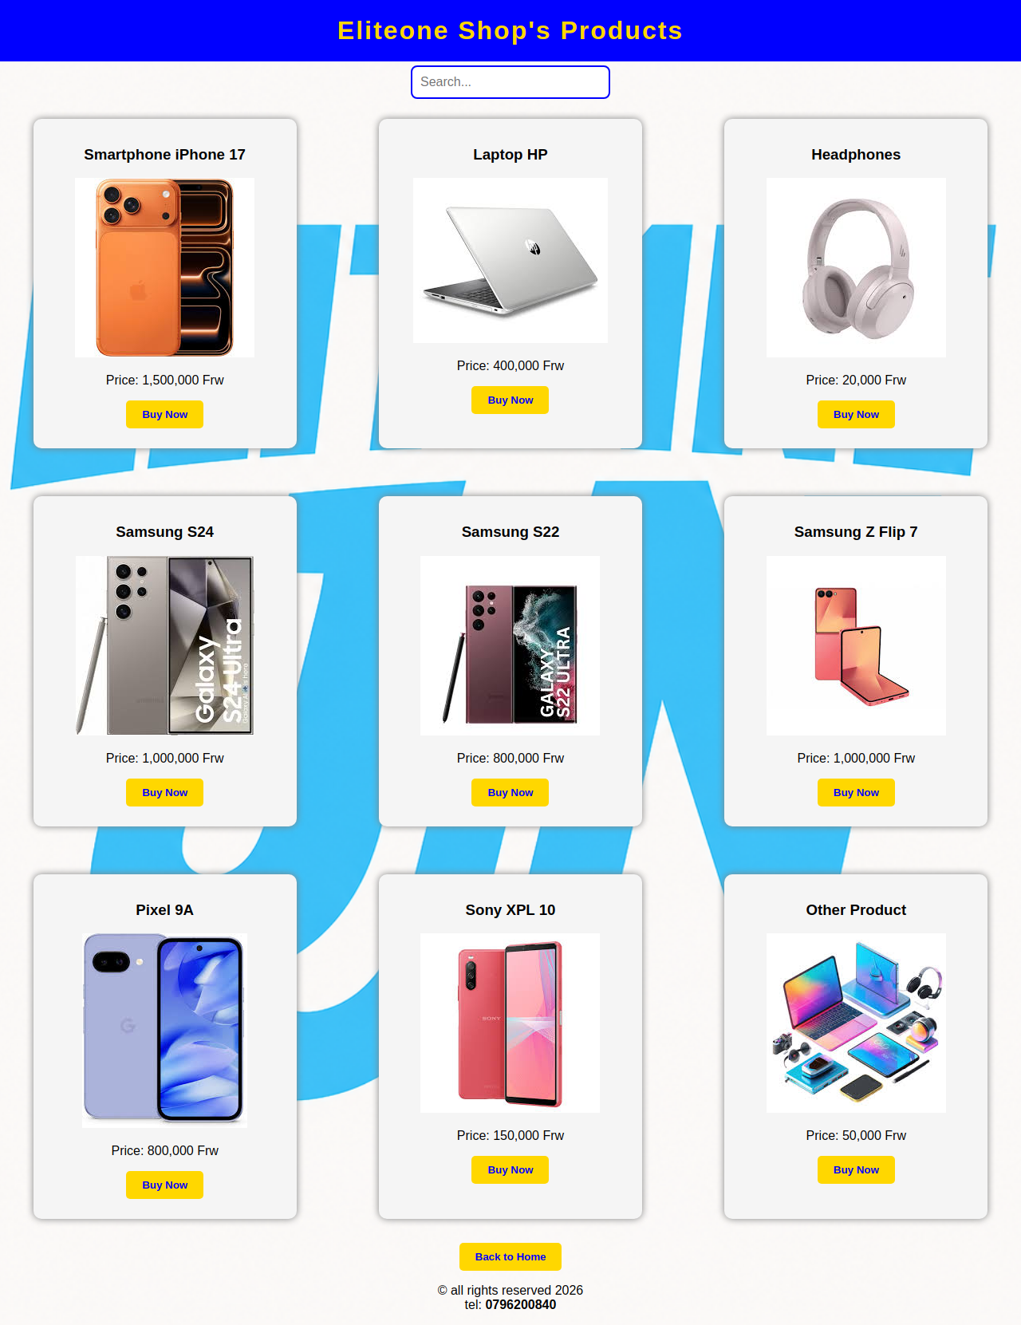
Figure 5: Product catalogue page (shop.html)
The shop page lists all available products as cards, each showing an image, name, price in Rwandan Francs (Frw), and a "Buy Now" button. Nine gadgets are listed by default (iPhone 17, HP Laptop, Headphones, Samsung S24, Samsung S22, Samsung Z Flip 7, Pixel 9A, Sony XPL 10, and one generic product). Any products the seller has added through the dashboard are appended dynamically from localStorage when the page loads. A live search box filters the visible product cards by name as the visitor types, using a keyup event handler.

3.5 Checkout Page
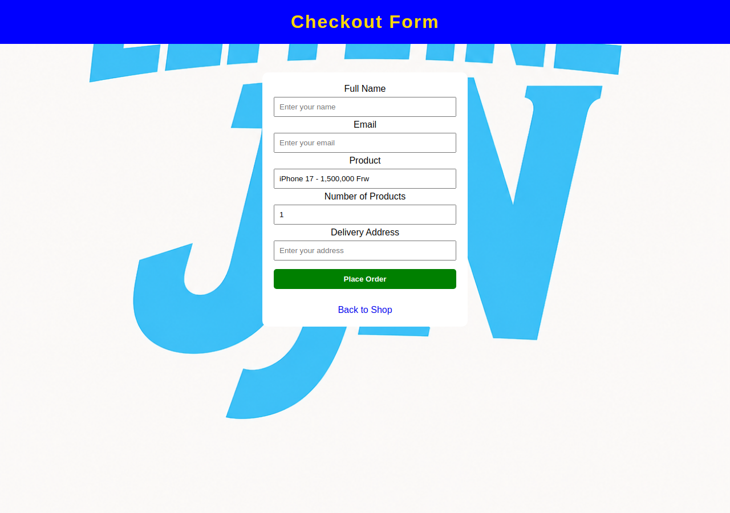
Figure 6: Checkout form (buy.html)
Clicking "Buy Now" on a product opens the checkout page with the selected product name and price pre-filled (read from the page's URL query parameters) and locked as read-only. The buyer fills in their full name, email, desired quantity, and delivery address, and submits the form.
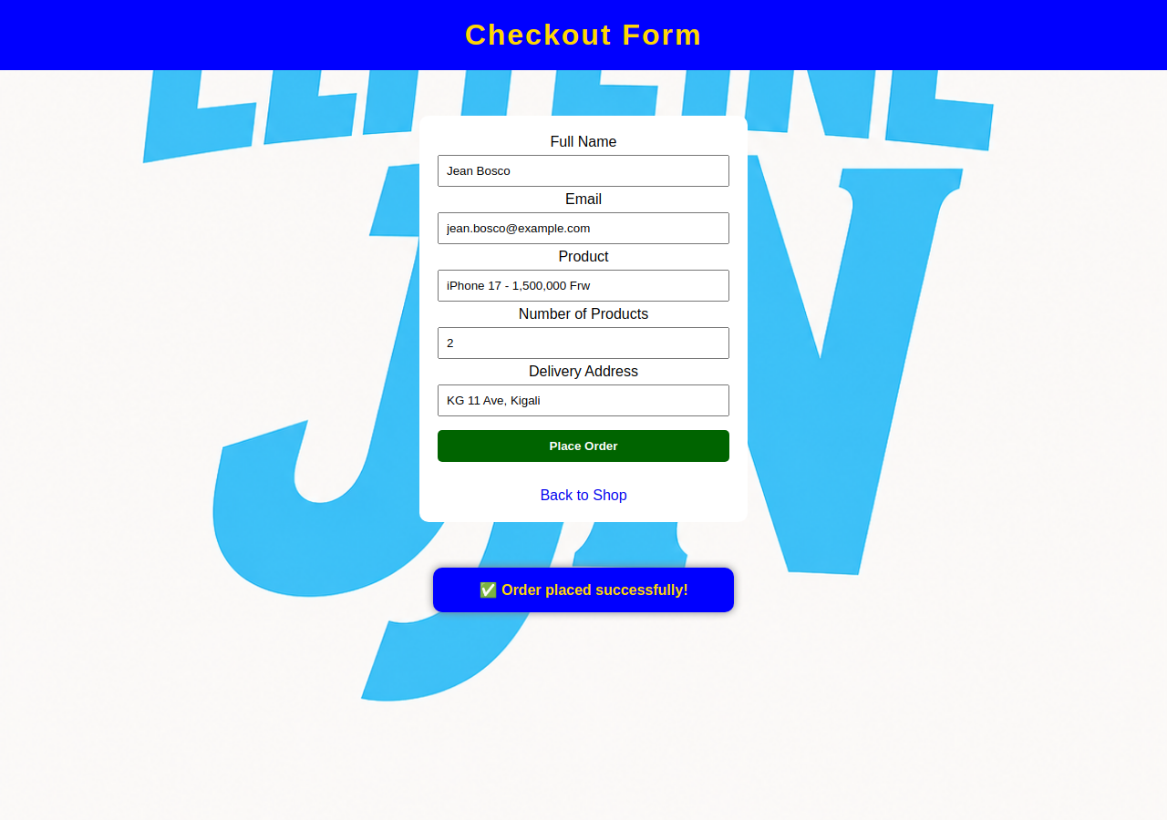
Figure 7: Order confirmation after checkout
On submission, the form is validated using the browser's built-in required-field and email-format validation. The order — including a generated ID and timestamp — is then saved into the "orders" array in localStorage with a status of "new", and a success banner ("Order placed successfully!") is shown for a few seconds.

3.6 Seller Dashboard – Add Product
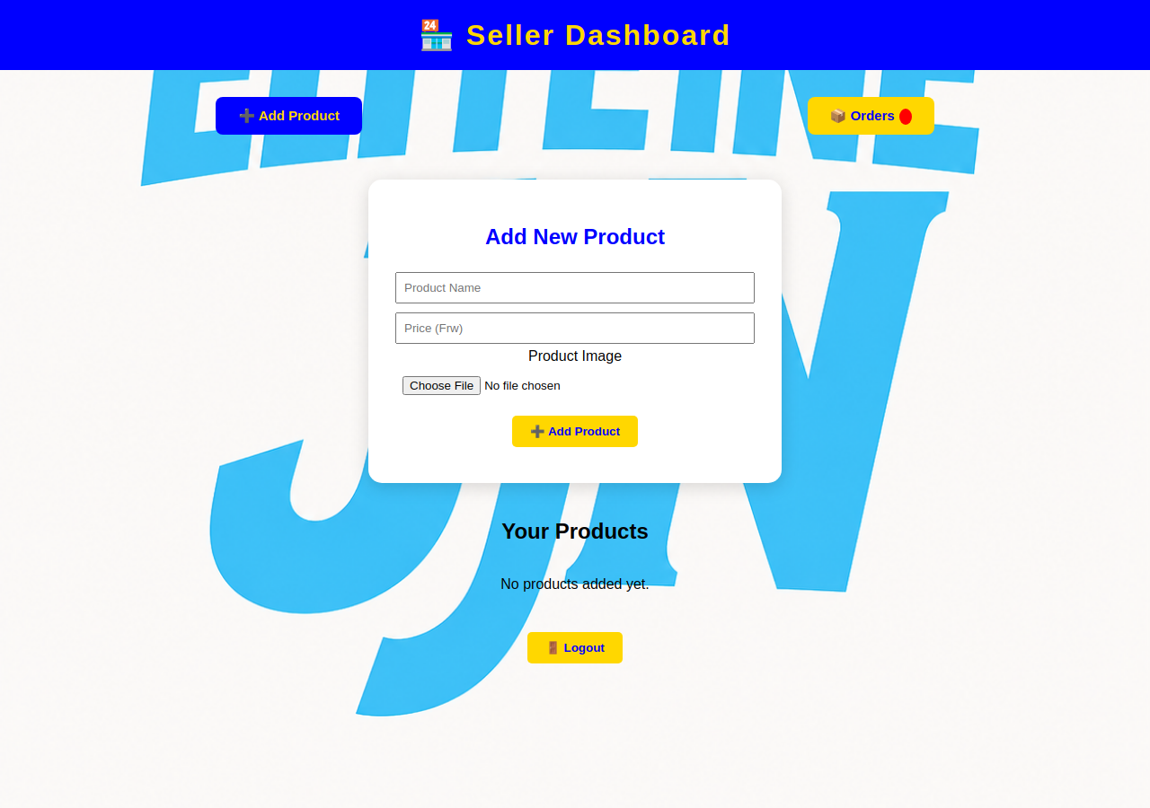
Figure 8: Seller dashboard – Add Product tab
After logging in, the seller lands on the dashboard's "Add Product" tab. This form takes a product name, a price in Frw, and an image file; selecting an image shows an instant thumbnail preview using the FileReader API. Submitting the form validates that all three fields are filled, then encodes the image as a base64 data URL and appends the new product object to the "products" array in localStorage, after which it immediately appears both in "Your Products" below the form and in the public shop catalogue.

3.7 Seller Dashboard – Orders
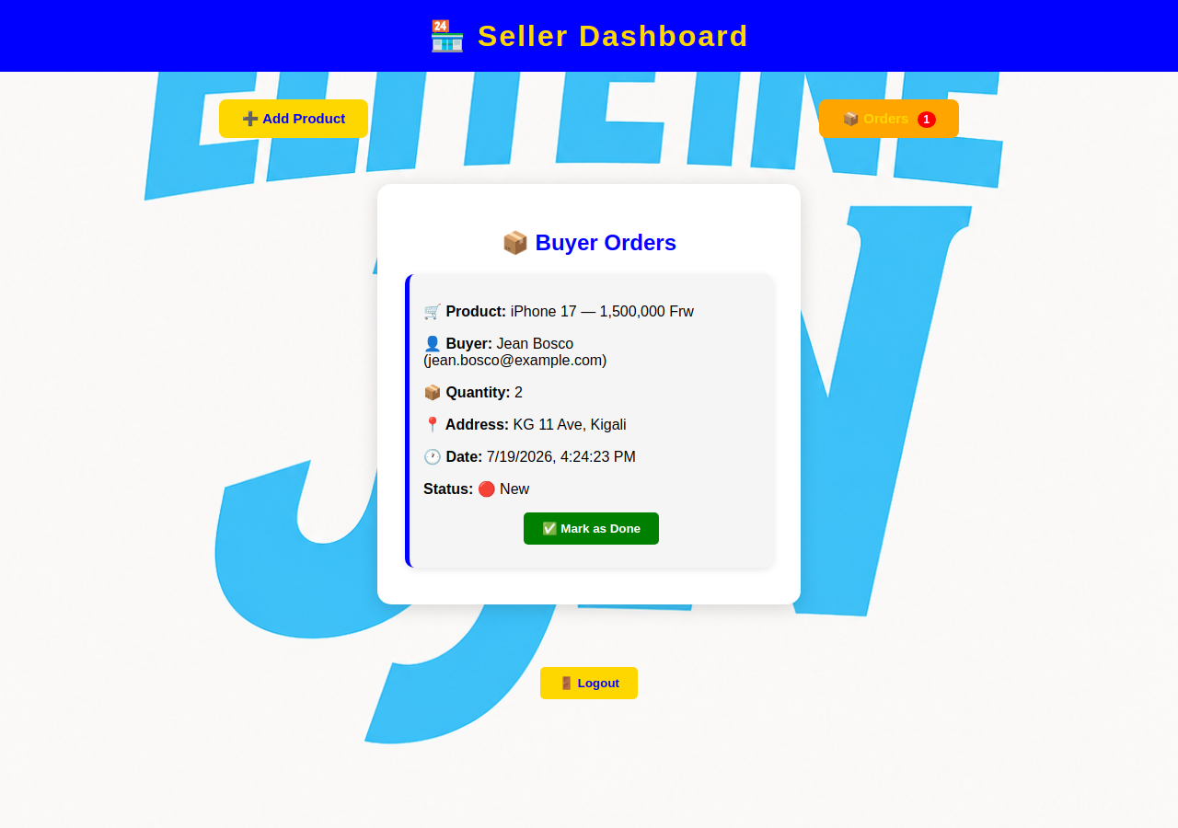
Figure 9: Seller dashboard – Orders tab, showing a live buyer order
The "Orders" tab lists every order placed through the checkout page, most recent first, showing the product, buyer name and email, quantity, delivery address, and timestamp. A red badge on the Orders tab button shows the count of orders still marked "new". Each new order has a "Mark as Done" button that updates its status in localStorage; completed orders are shown with a green accent and the Mark as Done button removed. A Logout button clears the sellerLoggedIn session flag and returns to the landing page; the dashboard itself also redirects back to index.html if accessed without a valid session.

Chapter 4. Conclusion and Recommendation
The implemented system achieves the core objectives set out in Section 1.3: buyers can browse and search the product catalogue and place orders through a working checkout flow, and the seller can securely log in, add products with images, and view and manage buyer orders. Based on the objectives stated, the system is estimated to have achieved roughly 80–85% of its intended scope. The main gap is that the platform currently has no backend server or real database — all data lives in the browser's localStorage and sessionStorage, which means products and orders are only visible on the same browser/device on which they were created, and the seller credentials are hardcoded in client-side JavaScript rather than stored and verified securely on a server.

Recommendations
- To the lecturer about technicalities: the current implementation is intentionally scoped to front-end HTML/CSS/JavaScript with browser storage; migrating products and orders to a real backend (e.g. a REST API with a relational or document database) would resolve the cross-device and multi-user limitations and is recommended as the natural next milestone.
- To the school about time constraints: the time allocated was sufficient to deliver a complete front-end experience (all four pages fully functional) but not enough to add a backend, authentication service, or payment integration; more time in a follow-up module would allow those additions.
- To the partners (the shop owner) about the app developed: the current version can be used immediately for a single seller on a single device/browser to showcase products and collect orders, but the hardcoded seller password should be changed and treated as temporary rather than production-grade security.
- To the user about training: the seller should be shown how to log in, add a product with a clear product photo, and check the Orders tab regularly, since orders are only stored locally and are not sent by email or SMS.
- To the beneficiaries (customers) about the new technological tool: buyers should be informed that placing an order through the site records their request with the seller but does not yet process online payment or send an automatic confirmation email — follow-up currently happens directly with the seller using the phone number listed on the site.

Appendix
Link to the account of the GitHub repository :
https://github.com/Sango03-jjn/Elite-shop

